Business Intelligence (BI) Portal
BI Portal Installation Instructions

Business Intelligence Portal
BI Portal Installation Instructions
Before You Start
Enterprise Software Solutions offers unlimited remote support during evaluation and initial product setup and configuration. If you need support, please don’t hesitate to contact us at: info@entsoftsol.com. Our technicians will instruct you to visit our Immediate Support page at: http://www.entsoftsol.com/Support/ImmediateSupport.aspx and will ask you to give them the ID and password. This will allow us to connect and interact with your session. This is the fastest way to address any problems. If your local network administrators do not allow remote support sessions, we will be happy to help you through emails and phone.
Once we have the Business Intelligence Portal working, please don’t hesitate to ask any technical or training questions.

The BI Portal supports Active Directory and Forms Based Authentication for the security layer, and SQL or SSRS authorization and reports storage. The installation also supports all features to be installed on one server and features to be installed on dedicated servers. For the purposes of this installation, we will use a clean installed Windows 2008 R2 x64 server and SQL 2008 R2 standard installation with SQL, SSAS and SSRS

BI Portal Overview
The Business Intelligence (BI) Portal is a centralized repository for reports, documents and generally any kind of files – pdf, wav, jpg, png, xls, doc, etc. It includes:
- the Business Intelligence (BI) Companion which is an advanced and interactive OLAP cube browser;
- the Report Server (RS) Companion which is a management and report delivery application for the MS Reporting Services;
- the Silverlight SSRS reports’ viewer which is a xaml rendering extension for the MS SSRS services; and it handles the storage/retrieval of reports and files based on SSRS or SQL Storage engine alongside with authentication and authorization.
The BI Portal is based on the Microsoft Silverlight technology, and executes 100% on the clients’ computer. When connecting to the MS SSAS server, it utilizes an xmla message pump which relays the requests to the SSAS server. Enterprise Software Solutions have extended the Microsoft’s xmla pump. When connecting to the MS SSRS Server it makes direct web services calls to the SSRS web services interface. The BI Portal also supports IIS server farms both in a session-full and session-less modes.

Deployment Scenario
This deployment scenario will support Active Directory Integrated users that access the BI Portal and the SSAS databases/cubes with their AD Accounts. Reports storage and authorization will be handled by the SSRS services.
The BI Portal offers users an xmla message pump that in turn connects to the SSAS server. The BI Portal supports windows integrated security that will allow for impersonation with specifying a domain account or it will preserve the end user security principal. For this setup we will preserve the end users’ credentials. This will allow all internal users to connect to the SSAS xmla message pump and be identified as AD accounts. Having the xmla message pump on the SSAS server allows us to use impersonation and preserve the connecting user AD account security context. It is also possible to install the BI Portal (xmla message pump) on a separate IIS server, but in order to preserve the AD account security context you will need to setup delegation which is outside of the scope of this document.
It is important that you test from a third computer/workstation, and not from the SSAS or IIS server. Requests initiated from the local SSAS or IIS server will preserve your current AD security context and mislead you. Request from a third workstation/server will cause impersonation to be stopped at the first contacted server and subsequent request will be initiated as Network Service or ServerName$ accounts.
The installation of the BI Portal involves several technologies. The number of possible permutations amongst servers, OS types, IIS versions, security, storage engine and protocols is very high. Therefore in this document we will consider a standard BI Portal setup with 1 dedicated server and 1 workstation.
- Clean install of Windows 2008 R2 x64 server with default IIS role installed
  - User Account Control turned off during installation
  - .net 2.0 and 3.5 installed, IIS integrated and aspx pages allowed
  - BI Portal application pool and virtual directory only accepting Windows Authentication
- SQL 2008 R2 installed with default settings
  - SSAS 2008 R2 with AD security configured
  - SSRS 2008 R2 for reports storage and authorization
- Windows 7 workstation with Silverlight v4. The workstation will connect to the BIPortal URL which should be configured as a local Intranet site allowing for AD credentials to be automatically used.
BI Portal Installation
Server Side:
The following list is Microsoft Components. Please check with Microsoft.com for installation details and best practices.
- Microsoft IIS server with .Net framework 2.0 and 3.5 configured to service .aspx and .svc content
- SSAS Server 2008 R2
- SSRS Server 2008 R2
The following Enterprise Software Solutions products are available for download from their respective links. Detailed installation instructions follow in this document:
- BI Portal Installation http://www.entsoftsol.com/downloads/BIPortal/BIPortal.zip
Client Side:
- Microsoft Silverlight 4 framework
http://www.microsoft.com/getsilverlight/Get-Started/Install/Default.aspx

Server Side Installation:
For prerequisites 1, 2 and 3 above please refer to Microsoft.com for detailed instructions.
Before continue, please perform the following checks to confirm proper configuration of the Microsoft products:
- Make sure that your .Net 2.0 framework is registered with IIS. Based on your OS type (32 or 64 bit) execute the “aspnet_regiis.exe -i” in the proper Framework directory.
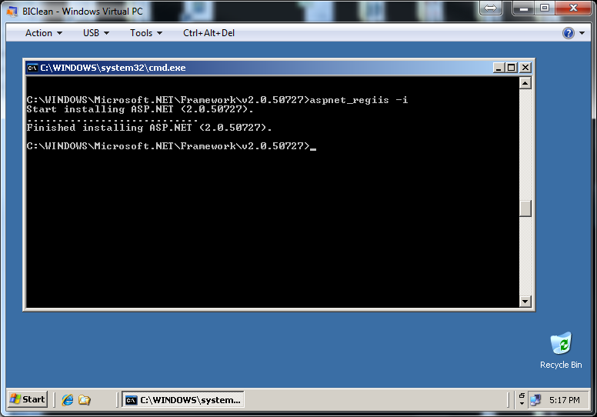

- Select the server home, double-click ISAPI and CGI Restrictions, and then allow ASP.NET v2.0.50727

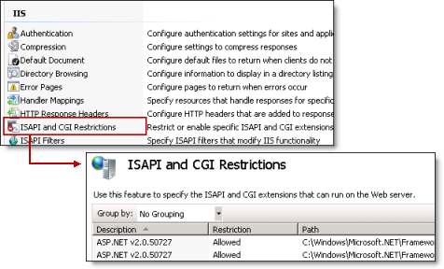

- Enterprise Software Solutions BI Portal Installation

- Configure your IIS
  - Download http://www.entsoftsol.com/downloads/BIPortal/BIPortal.zip to your downloads folder or your desktop. If you are using Windows 2008 R2+, make sure that the file is Unblocked. To unblock it, right click on the downloaded biporta.zip file and select properties. Click Unblock button at the bottom of the window.
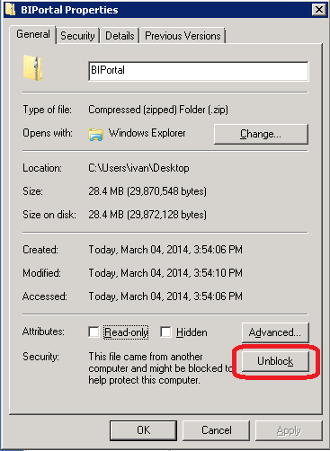

  - Under the default web site, subfolder called BIPortal. Unzip the biportal.zip file into this folder and make sure that you don’t end up with another SubFolder called BIPortal. Right click on the folder and under security make sure that NetworkService account has full rights to the folder. If NetworkService is not there, click Add and add the account, then apply the security to all subfolders if necessary.
  - In the IIS manager under Application Pools add a new Application Pool called BIPortal with .net framework 2.0 and Classic mode. Right click on the new BIPortal application pool, select Advanced Settings and change the Identity to NetworkService.
  - Under Default Web Site right click on the BI Portal subfolder and select Convert to Application. Click the Select button and choose the BIPortal Application Pool.
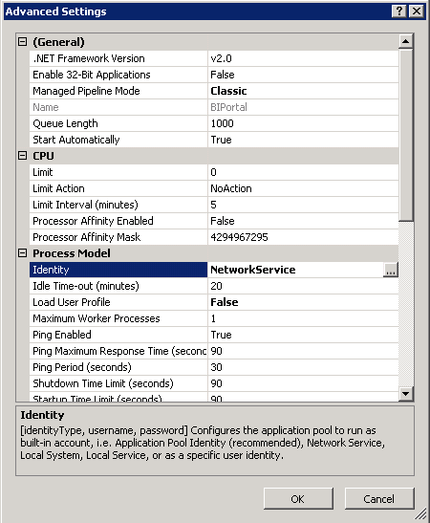
  - Explore to the Root of the BI Portal folder, go to Admin subfolder and copy the Web.ssrs-windows.config file to the root folder. Then rename it to web.config. Open the web.config file in the root of the web site and modify:
      - AdminADGroupName – change to your Domain Admins group
      - SSASConnectionString. In the Data Source = change the SSASSERVER with the name of your SSAS server.
      - Go through the rest of the App Settings and Email Settings and change as necessary. These all are optional. For example. If you are going to use the BI Portal Email delivering system then under ServiceSettings modify BIPortalUrl – change to your URL Address http://server/biportal, and so on.
  - Explore to the Root of the BI Portal folder, go to ClientBin subfolder. Copy the SilverlightBI.default.xap.xml and paste it in the same folder. Rename the copy to SilverlightBI.xap.xml. Go one level up to the root of the BI Portal folder and then into the Admin folder. Start the BIPortal.Helper.exe application. When the application starts you will see three columns. The left most one is the Setting Name (Key), the middle one is the Default Settings that come with a clean installation. The right most one is your installed/live settings. Make changes to the right most column.
On the left side, type in “endpoint” in the search box
Modify the SSRSReportManagerEndpoint and SSRSEndpoint to your http://server/reports and http://server/reportserver urls. These are your SSRS urls.
Change ServicesEndpoint to reflect your installation URL - http://biclean/biportal/services/ in this installation.
In this example, I changed everything that starts with http://demoserver.entsoftsol.com to start with http://biclean.
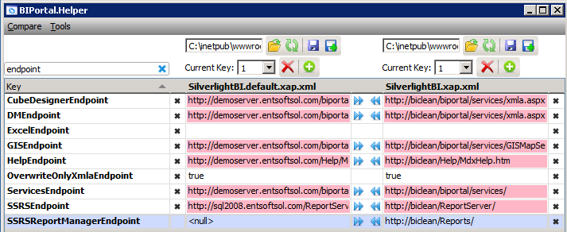
Also adjust the following elements to represent your SSAS server and databases:
Datasource ssasServer
Database Adventure Works DW 2008R2
Cube Adventure Works
Perspective Channel Sales

When ready click on the top right Diskette (without the + sign) to save the SilverlightBI.xap.xml file above the right column.
  - In the ISS Manager, expand the Default Web Site, right click on the BI Portal subfolder and select Convert to Application. Make sure to select the BIPortal application pool.
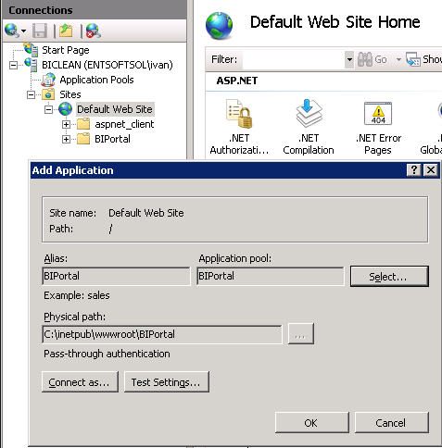
  - Click on the BI Portal subfolder and on the right side select Authentication. Make sure to disable Anonymous and enable Windows Authentication
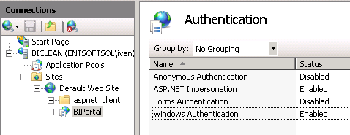
  - Now you need to test. Connect to http://biclean/BIPortal/Services/MembershipService.asmx. You should see the MembershipService endpoint. 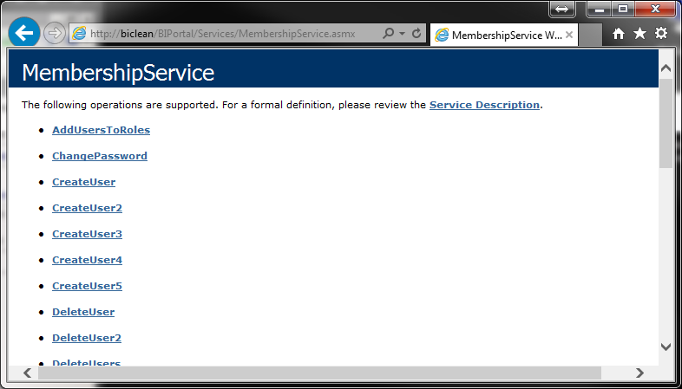

  - At this point browse http://biclean/BIPortal/Home.aspx. Once BIPortal loads, click on the Info button and make sure that username, authnmode and storage are all properly configured:
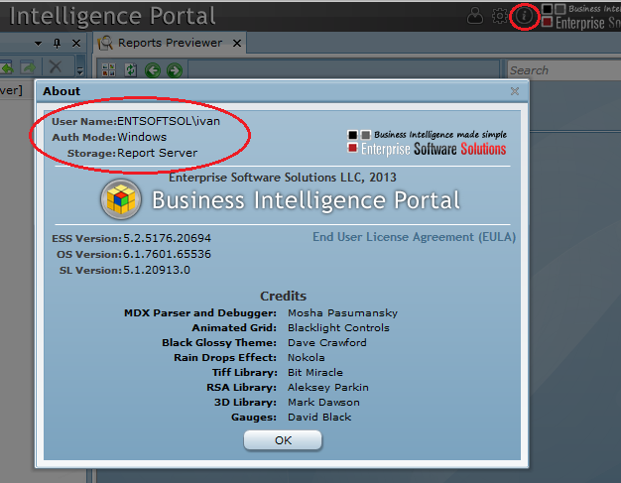
  - On older IIS version you need to configure the IIS virtual directory to service .xap MIME types. Right click on BIPortal, select Properties. Under the HTTP Heathers, select MIME Types, click New and type in “.xap” for Extension and “application/x-silverlight-app” for MIME type.

  - On the SSAS server install the extension libraries. Please navigate to the webroot\BIPortal\_Install\SSASLibraries and follow the SetupInstructins.txt document.

  - Install XAML Rendering extensions
Explorer to the BI Portal Root folder then to the webroot\BIPortal\ _Install\SSRSXamlRendering subfolder.
Double click to start ESS.ReportingServices.Extensions.Installer. On the left side check the checkbox next to your SSRS server. Select Request License. This will create a new xml file in the same folder. Please email it to use to activate your license. When you receive the license file, copy it to the same folder.
On the left side check the checkbox next to your SSRS server. Notice that Extensions Installed should be False. Click on the Apply button. It will change to True. Click restart Services to activate it.
  - Once the BI Portal has started, click on the start button, new, New Ad-Hoc Report using MS Analysis Services
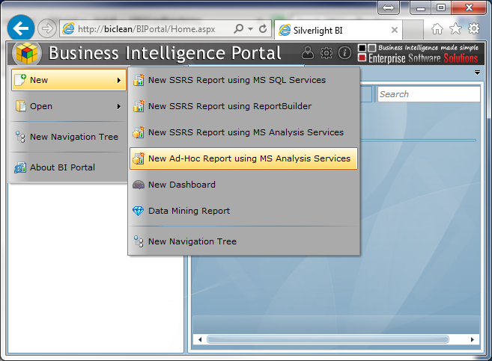

If you have configured properly your SSAS server, database, cube and perspective you should see the Connect To window prepopulated with the settings. Click OK.
Open the properties and request a license. The license request will be copied to your clipboard, so start a new email and paste it. Email to licensing@entsoftsol.com
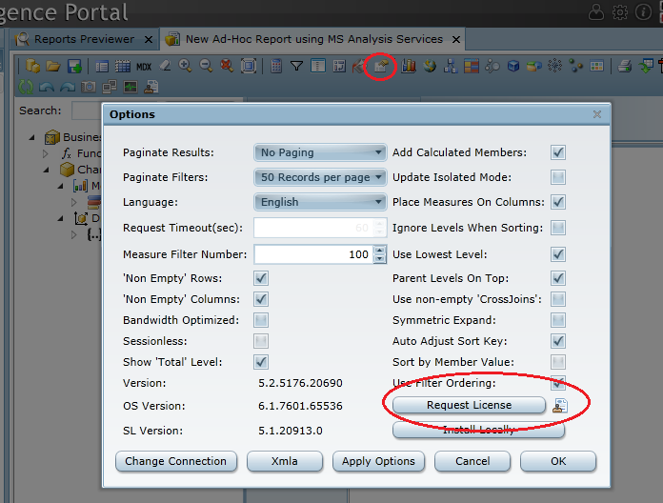
Once you receive the license file, rename it to License.xml and copy it to your ClientBin folder.

