Business Intelligence (BI) Companion
Xmla Message Pump and BI Companion Installation Instructions

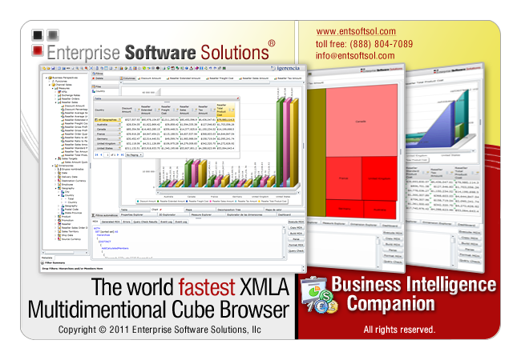

Business Intelligence Companion
Xmla Message Pump and BI Companion Installation Instructions
Overview
The Business Intelligence (BI) Companion is a very advanced and interactive OLAP cube browser. It is based on the Microsoft Silverlight technology, and executes 100% on the clients’ computer. When connecting to the MS SSAS server, it utilizes an xmla message pump which relays the requests to the SSAS server. The xmla message pump can be configured on the SSAS server itself, or on a separate server. The BI Companion also supports IIS server farms both in a session-full and session-less modes. Enterprise Software Solutions have written an easy to setup xmla pump that is an aspx page. It does not require any special configuration as long as the IIS server allows for .Net and aspx pages to be served.

Prerequisites installation
Before you start the installation process, please make sure the following prerequisites are installed:
Server Side:
- Microsoft IIS server with .Net framework 2.0
http://msdn.microsoft.com/en-us/netframework/aa731542.aspx
- Microsoft IIS server configured to service aspx content
- Microsoft or Enterprise Software Solutions XMLA Message Pump
http://www.entsoftsol.com/downloads/BICompanion/xmla.zip
- BI Companion
http://www.entsoftsol.com/downloads/BICompanion/BICompanion.zip
Client Side:
- Microsoft Silverlight 4 framework
http://www.microsoft.com/getsilverlight/Get-Started/Install/Default.aspx

Server Side Installation:
- Microsoft IIS server with .Net framework 2.0
For steps to install and configure the IIS server and .Net framework 2.0 please refer to the Microsoft’s online documentation.
- Microsoft IIS server configured to service aspx content
- Make sure that your .Net 2.0 framework is registered with IIS. Based on your OS type (32 or 64 bit) execute the “aspnet_regiis.exe -i” in the proper Framework directory.
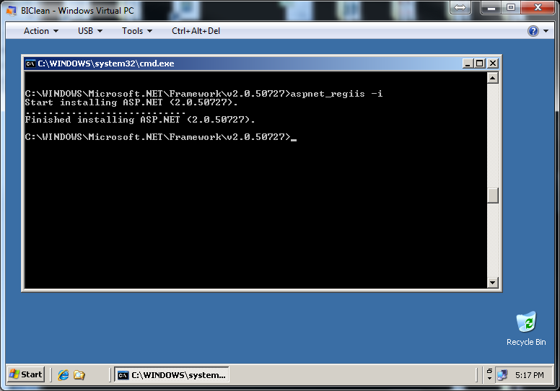

- Open your IIS server Web Service Extensions, select ASP.Net v2.0.xxxx and click Allow
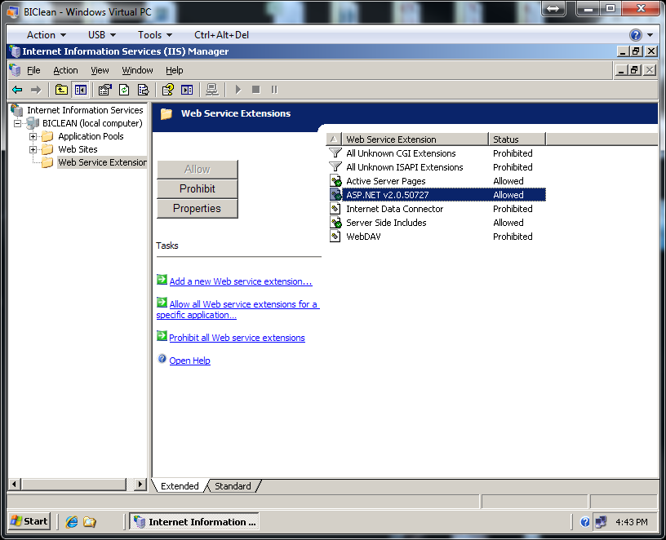

- Microsoft or Enterprise Software Solutions XMLA Message Pump
- Confirm that your Web Site is configured to run in .Net 2.0
Right click on the Default Web Site and select Properties. Go to the ASP.Net tab and confirm that you can see ASP.Net version: 2.0.xxx
- Unzip the http://www.entsoftsol.com/downloads/BICompanion/xmla.zip file to the root of the web site. Copy clientaccesspolicy.xml and crossdomain.xml files from the xmla folder to the root of the web site. This is required for the Silverlight application to be able to access the xmla message pump.

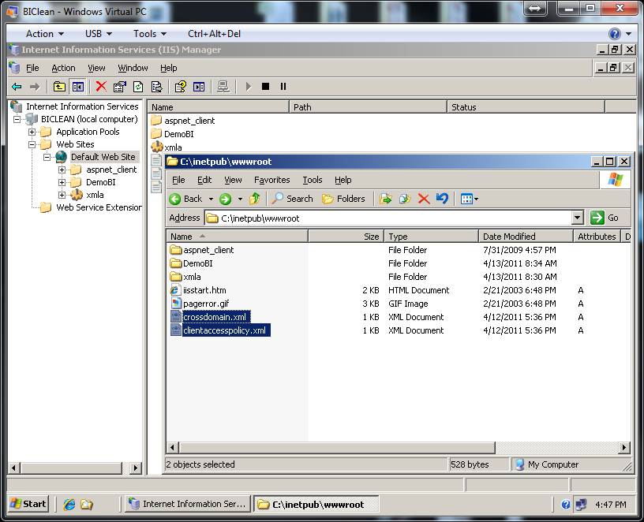

- Open the web.config file and configure the SSASConnectionString to point to your MS Analysis Server.
The default value will connect your xmla message pump to our message pump, which is good for testing : <add name="SSASConnectionString" connectionString="Data Source=http://demoserver.entsoftsol.com/xmla/default.aspx;"/>

Your settings should look like this:
<add name="SSASConnectionString" connectionString="Data Source=localhost;"/>
or
<add name="SSASConnectionString" connectionString="Data Source=ServerName\InstanceName;"/>

- Inside IIS server, right click on Application Pools, select New -> Application Pool. Call it xmla and select the default settings.
- Inside IIS server, refresh your Web Sites, expand your web site and confirm you can see the xmla directory. Right click on the xmla folder, select Properties. In the Directory tab, click Create under Application settings. Type in xmla as Application name, and select xmla as the Application Pool.

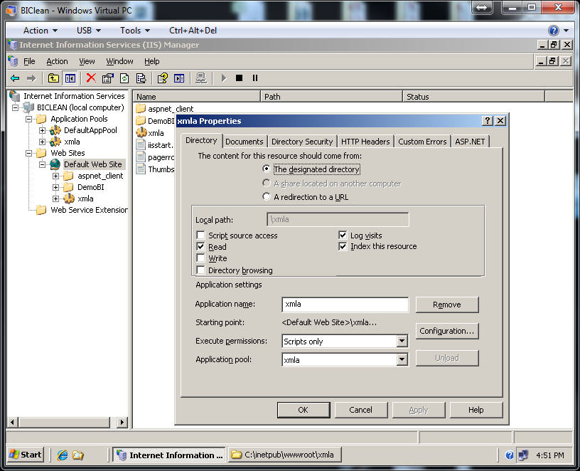

Go to the Directory Security tab and under Authentication and access control, click Edit. Uncheck the Enable anonymous access and check Integrated Windows authentication.

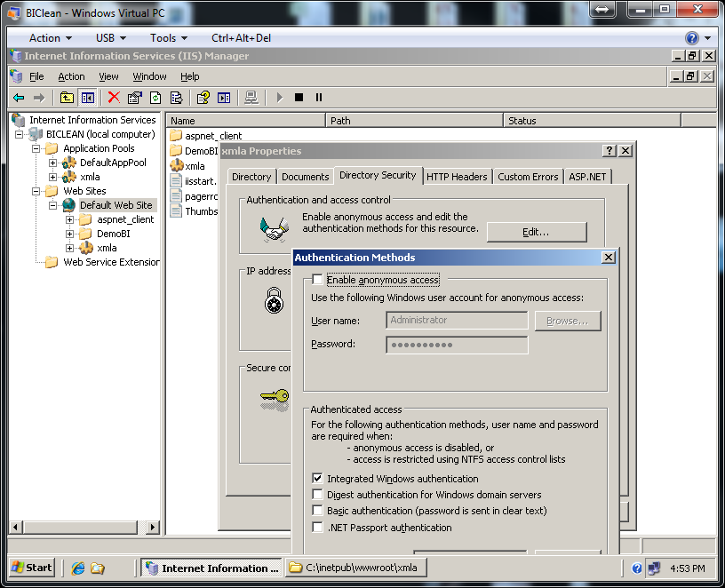

Select Ok and Ok to save the changes.
- At this your xmla pump is set. Test it by opening the MS Management Studio, select Connect to Analysis Server and in the box “Server Name”, instead of typing your server name, use the http address of your message pump. Click Connect and confirm that you can connect to your SSAS Server. This will also confirm your security rights and the databases that you can see:
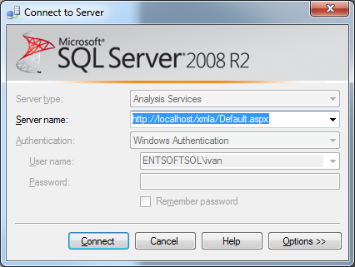

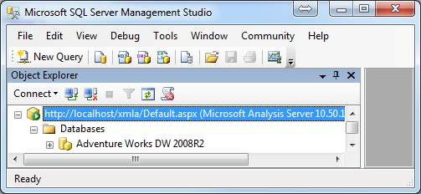

- BI Companion
The BI Companion consists of 3 files
- BICompanion.xap which is the core of the application. This is a Silverlight application, so you can use the xap file to embed the BI Companion in any Silverlight container. When we have new versions, we only deploy the new xap file. Overwriting the xap file updates your server and every client (upon restarting the application). Therefore maintenance and support for many users is very easy.
- BICompanion.xap.xml is the configuration files. This file can be part of the xap file, but we keep it as a separate file so you can easily make changes to the settings. For now, open the file in any text editor and adjust the following sections to represent your xmla pump, SSAS server, database, cube and perspective:

<KeyValueOfstringstring>
<Key>XmlaServer</Key>
<Value>http://localhost/xmla/</Value>
</KeyValueOfstringstring>

<KeyValueOfstringstring>
<Key>Datasource</Key>
<Value>bi\sql2008</Value>
</KeyValueOfstringstring>
<KeyValueOfstringstring>
<Key>Database</Key>
<Value>Adventure Works DW 2008R2</Value>
</KeyValueOfstringstring>
<KeyValueOfstringstring>
<Key>Cube</Key>
<Value>Adventure Works</Value>
</KeyValueOfstringstring>
<KeyValueOfstringstring>
<Key>Perspective</Key>
<Value>Channel Sales</Value>
</KeyValueOfstringstring>

- The Default.htm page simply starts the BI Companion application. It can also include java script handlers for file storage and loading. The default behavior of the BI Companion is to save and open files directly from your local file system.

- You need to configure the IIS virtual directory to service .xap MIME types. Right click on BICompanion, select Properties. Under the HTTP Heathers, select MIME Types, click New and type in “.xap” for Extension and “application/x-silverlight-app” for MIME type.
At this point, you have setup your BI Companion. Go ahead and browse it http://localhost/bicompanion/.
Installation and Evaluation Support
Enterprise Software Solutions offers unlimited remote support during evaluation and initial setup/configuration. If you need support, please don’t hesitate to contact us at: info@entsoftsol.com. Our technicians will instruct you to visit our Immediate Support page at: http://www.entsoftsol.com/Support/ImmediateSupport.aspx and will ask you to give them the ID and password. This will allow us to connect and interact with your session. This is the fastest way to address any problems. If your local network administrators do not allow remote support sessions, we will be happy to help you through emails and phone.

Once we have the Business Intelligence Companion working, please don’t hesitate to ask any technical or training questions.

